SAP ALE Demo (Student Management using EDI/IDoc exchange between 2 SAP Systems Ministry (Ministry & Faculty )
Oct 20, 2026 · @Mohamed ABDELMOULA
This page documents a demo application exchanging EDI/IDoc between two SAP systems through ALE: a ministry system that holds the national list of students, and a faculty system that manages the assigned students.
The example is educational but very close to a real deployment: same transactions, same objects, same pitfalls. It also serves as a reusable base for other developments.

The need
A ministry keeps the national list of students with all their details. When a student is assigned to a faculty, the ministry system must send their record to the faculty management system, which then integrates the student into its own database. In the other direction, the faculty reports the student's life events back to the ministry: result (pass or fail), average, death, left, university transfer request, and so on.
So we have two autonomous systems that must exchange structured data reliably and asynchronously (each system stays available even if the other is momentarily down). This is exactly what SAP designed ALE and IDocs for. Rather than using a standard message type, we create a custom one, exactly as SAP does for its own objects (MATMAS for materials, DEBMAS for customers, and so on), applied here to students.

The flow in theory
Two flows, in opposite directions, rely on a single message type ZSTUD that carries two basic types (the MATMAS-style model):
Flow | Direction | Basic type | Content
Assignment | Ministry to Faculty | ZSTUD01 | The student and their assigned specialization
Events | Faculty to Ministry | ZSTUD02 | Result, average, death, university transfer
The end-to-end mechanics are the same in both directions:
- An outbound program reads the application data and fills an IDoc (control record + segments).
- The ALE distribution model determines the receiver from the sending system and the message type.
- The IDoc is transmitted over tRFC to the target system, through a port and an RFC destination.
- On the receiving side, the partner profile and the process code route the IDoc to an inbound function module.
- That function module reads the segments and posts the data into the receiver's application tables.
The elegant point of the design: each system only sends its own basic type (the ministry sends ZSTUD01, the faculty sends ZSTUD02), while it remains the same message type ZSTUD. That is what allows a single channel to carry two distinct data structures depending on direction.
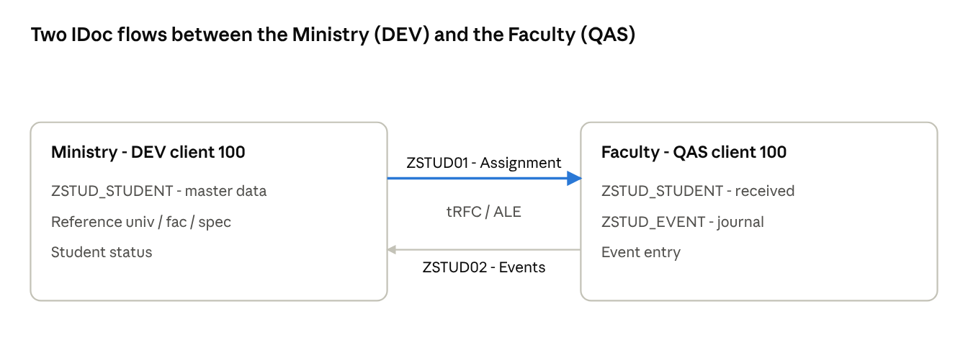
Landscape - les deux flux IDoc entre S4D et S4Q
Assignment flows down from the ministry to the faculty (ZSTUD01); events flow back up from the faculty to the ministry (ZSTUD02), over tRFC.

The data model
The model rests on two layers: the application tables (the real data, stored in each system) and the IDoc structures (the exchange format that travels over the network).
Two application tables, shared by the two systems (on the ministry side they hold the master data, on the faculty side the received data):
- ZSTUD_STUDENT: the student base (ID, identity, university/faculty/specialization codes, average).
- ZSTUD_EVENT: the event log (event type, status, average, target university, reason).
Two IDoc basic types, each made up of hierarchical segments:
- ZSTUD01: Z1STUHDR (student header) + Z1STUAFF (assignment).
- ZSTUD02: Z1EVTHDR (event header) + Z1EVTDAT (event data).
Two important rules of the model:
- In an IDoc, every segment field is of character type. Dates travel as CHAR 8 (YYYYMMDD), averages as CHAR. The real typing (DATS, DEC) lives only in the application tables.
- Universities and faculties are data, not systems. They are identified by a code (CODE_UNIV, CODE_FAC) carried in the IDoc. So you can manage as many universities as you like on a single faculty system, without changing the IDoc structure at all.
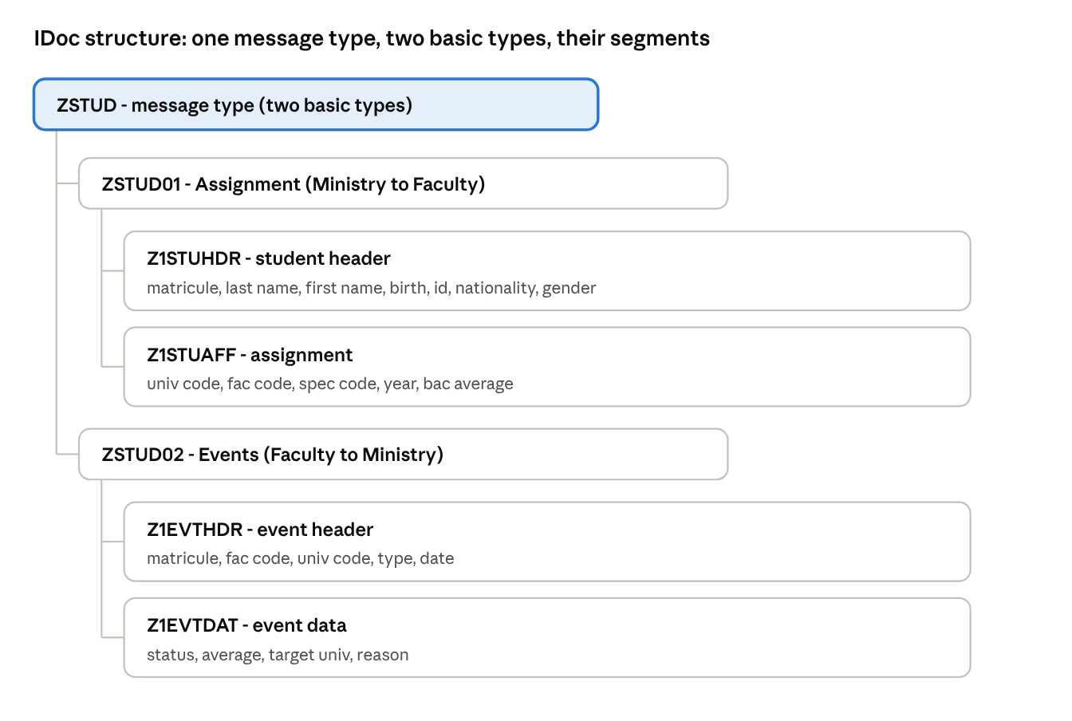
Structure des IDoc - basic types et segments
A single message type carries both basic types, and each basic type composes its segments, header then detail.

An educational example on ABAP Platform
This project is deliberately simple, but it is no toy: it uses exactly the same transactions, the same objects and the same ALE chain as a real production deployment. The pitfalls you hit along the way (releasing segments, the outbound format, the inbound function module interface) are the same as on a real project, and that is precisely where the exercise earns its value.
An important point: all of this runs on a plain ABAP Platform 2023 server, not on a full product like S/4HANA. It shows you don't need a business product installed to develop real custom solutions. An ABAP Platform server is enough to build and run your own objects: tables, IDocs, programs, ALE configuration, function modules. It is a full-fledged development platform.
Finally, this build is not an end in itself: it serves as a reusable base for other topics. Once the ALE/IDoc mechanics are mastered and the skeleton is in place, you can re-derive it for other system-to-system exchange cases, or use it as a testing ground for new developments.

Roadmap
The project is built in 4 phases. This document covers them, from the data foundation through to the full flow, with the pitfalls met along the way.
- Data foundation: application tables, segments, basic types, message type, links. (this phase)
- ALE config: logical systems, RFC destinations, ports, distribution model, partner profiles.
- Application layer: outbound FM (fill the IDoc), inbound FM (post into the tables), process codes, sending report.
- Test and monitoring: WE19, BD87, WE02.

Demo topology
The landscape chosen for the demo: the Ministry is on system DEV (client 100), the Faculty on system QAS (client 100). Two separate SAP systems linked by ALE, with the TMS configured to transport the objects from DEV to QAS.
The custom objects are developed on DEV and then transported to QAS, since they must exist on both sides for the exchange to work. The partner profiles, on the other hand, are created directly on each system (they are not transported).

Application tables (SE11)
Two transparent tables. Technical settings for both: delivery class A, data class APPL0, size 0, maintenance Display/Maintenance allowed. Activate after creation.

ZSTUD_STUDENT
Student base: master table on the ministry side (client 100), and arrival table on the faculty side (client 200).
Field | Key | Type | Len | Dec | Text
MANDT | X | CLNT (DE MANDT) | 3 |  | Client
MATRICULE | X | CHAR | 10 |  | Student ID
NOM |  | CHAR | 40 |  | Last name
PRENOM |  | CHAR | 40 |  | First name
DATENAIS |  | DATS | 8 |  | Date of birth
CIN |  | CHAR | 8 |  | National ID
NATIONALITE |  | CHAR | 3 |  | Nationality
SEXE |  | CHAR | 1 |  | Gender
CODE_UNIV |  | CHAR | 10 |  | University code
CODE_FAC |  | CHAR | 10 |  | Faculty code
CODE_SPEC |  | CHAR | 10 |  | Specialization code
ANNEE_UNIV |  | CHAR | 9 |  | Academic year
MOY_BAC |  | DEC | 5 | 2 | Baccalaureate average

ZSTUD_EVENT
Event log: the faculty writes (client 200), the ministry receives (client 100).
Field | Key | Type | Len | Dec | Text
MANDT | X | CLNT (DE MANDT) | 3 |  | Client
MATRICULE | X | CHAR | 10 |  | Student ID
SEQNR | X | NUMC | 6 |  | Event sequence no.
TYPE_EVT |  | CHAR | 10 |  | Type (RESULT/DECES/CHANGE)
DATE_EVT |  | DATS | 8 |  | Event date
STATUT |  | CHAR | 10 |  | SUCCES / REFUSE
MOYENNE |  | DEC | 5 | 2 | Average
UNIV_CIBLE |  | CHAR | 10 |  | Target university (transfer)
MOTIF |  | CHAR | 60 |  | Reason
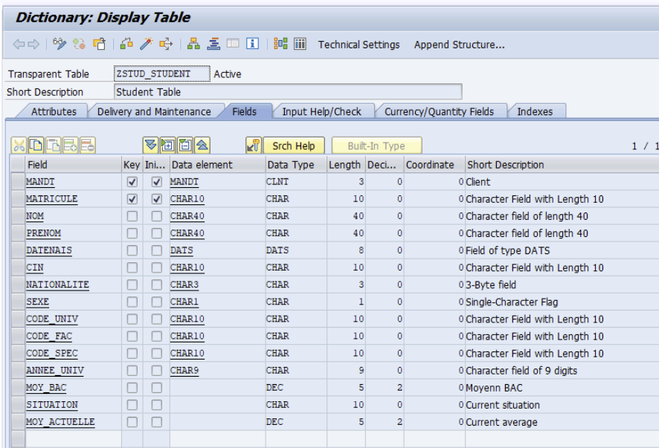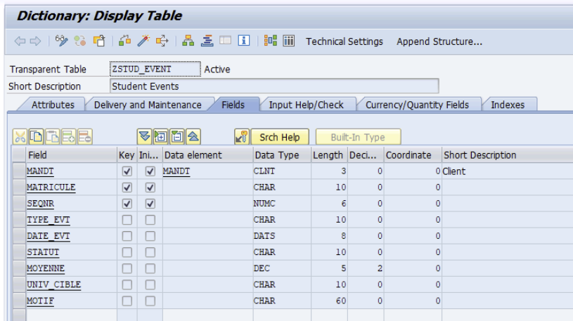

Segments (WE31)
For each segment: WE31, enter the name, then the fields. Leave the Data element column empty and fill in Data Type = CHAR and Length directly. Save, then activate each segment (it creates the Z1... version and the definition).
Segment | Role | Fields (all CHAR)
Z1STUHDR | Student header | MATRICULE 10, NOM 40, PRENOM 40, DATENAIS 8, CIN 8, NATIONALITE 3, SEXE 1
Z1STUAFF | Assignment | CODE_UNIV 10, CODE_FAC 10, CODE_SPEC 10, LIB_SPEC 40, ANNEE_UNIV 9, MOY_BAC 5, DATE_AFFECT 8
Z1EVTHDR | Event header | MATRICULE 10, CODE_FAC 10, CODE_UNIV 10, TYPE_EVT 10, DATE_EVT 8, ANNEE_UNIV 9
Z1EVTDAT | Event data | STATUT 10, MOYENNE 5, SESSION 10, UNIV_CIBLE 10, FAC_CIBLE 10, MOTIF 60
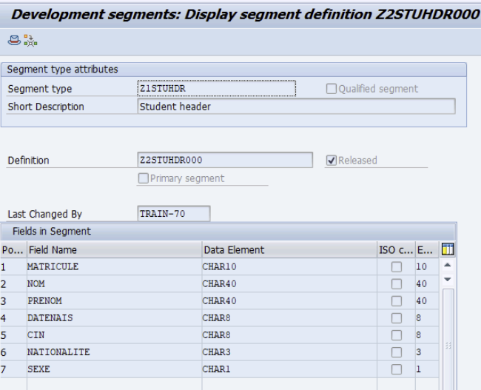
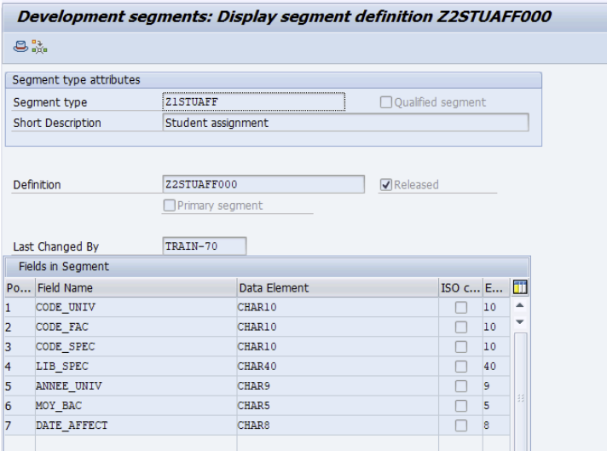
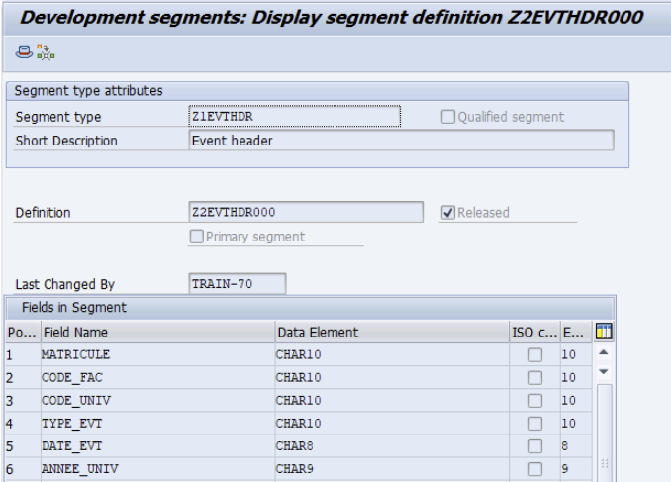
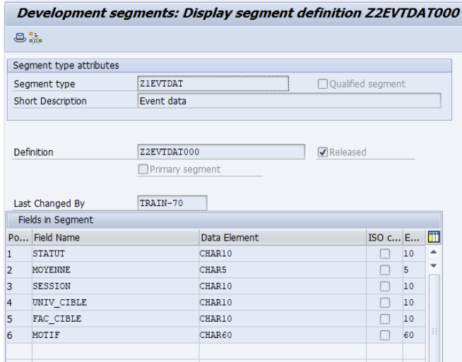

Basic types (WE30)

ZSTUD01 (assignment, Ministry to Faculty)
- Add Z1STUHDR at the root level: mandatory, min 1 / max 1
- Add Z1STUAFF as a child of Z1STUHDR: mandatory, min 1 / max 1

ZSTUD02 (events, Faculty to Ministry)
- Z1EVTHDR root: mandatory, min 1 / max 1
- Z1EVTDAT child of Z1EVTHDR: optional, min 0 / max 1
Activate both basic types.
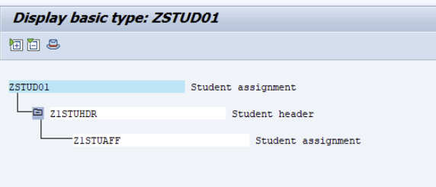

Message type and links
- WE81: create the message type ZSTUD.
- WE82: two rows, same message type, two basic types:
  - ZSTUD + ZSTUD01
  - ZSTUD + ZSTUD02
- (Release: the SAP version proposed by default.)
It's this double attachment in WE82 that concretely realizes the idea of one message type with two basic types, MATMAS-style.

Build order
Tables, then segments, then basic types, then message type, then WE82. Once everything is active with no errors, move on to phase 2 (two-client ALE config).
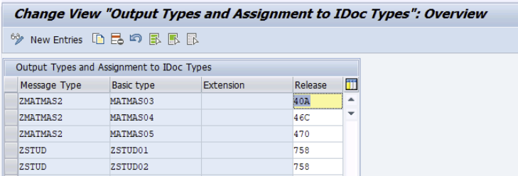

Phase 2: ALE configuration
Once the data objects are in place, you build the ALE exchange channel between DEV and QAS. The building blocks, in order:
- Logical systems (BD54): DEVCLNT100 (Ministry) and QASCLNT100 (Faculty), known to both systems. Already present here, as the landscape is pre-configured.
- RFC destinations (SM59) in both directions: QAS_UM on DEV, DEV_UM on QAS. They connect through a service user 8TECH_RFC of type System.
- Security without SAP_ALL: a dedicated role (Z_BC_ZSTUD_RFC) carries only the strict minimum, mainly the S_RFC object (function groups ARFC, EDIN, etc.) and B_ALE_RECV (EDI_MES = ZSTUD).
- tRFC ports (WE21): one port on each side, pointing to the RFC destination, in IDoc 4.x format (crucial, see the pitfalls).
- Distribution model (BD64): ZSTUD_MDL with both flows (DEV to QAS and QAS to DEV). Defined manually on each system rather than distributed automatically.
- Outbound partner profiles (WE20): on DEV the outbound parameter for ZSTUD/ZSTUD01, on QAS for ZSTUD/ZSTUD02.
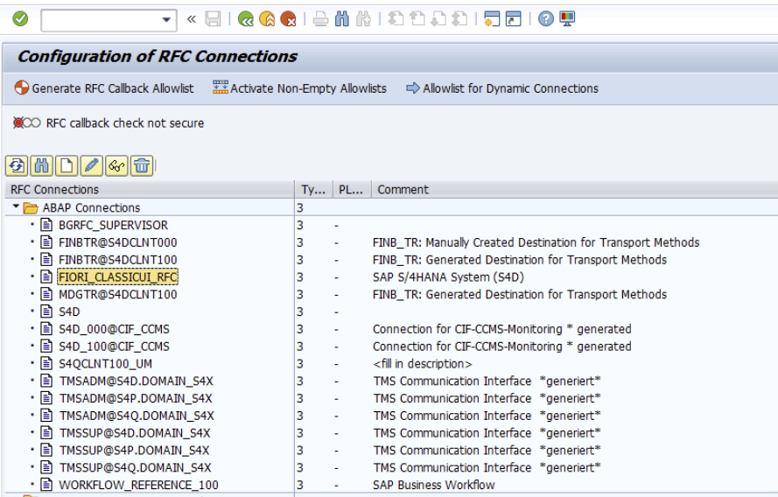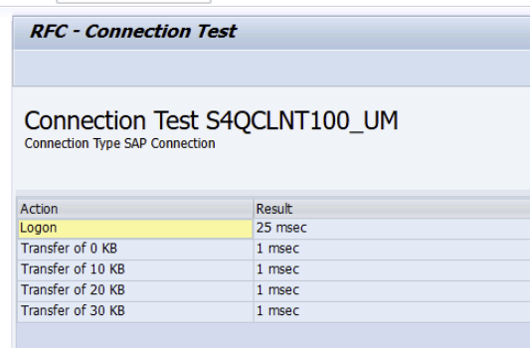
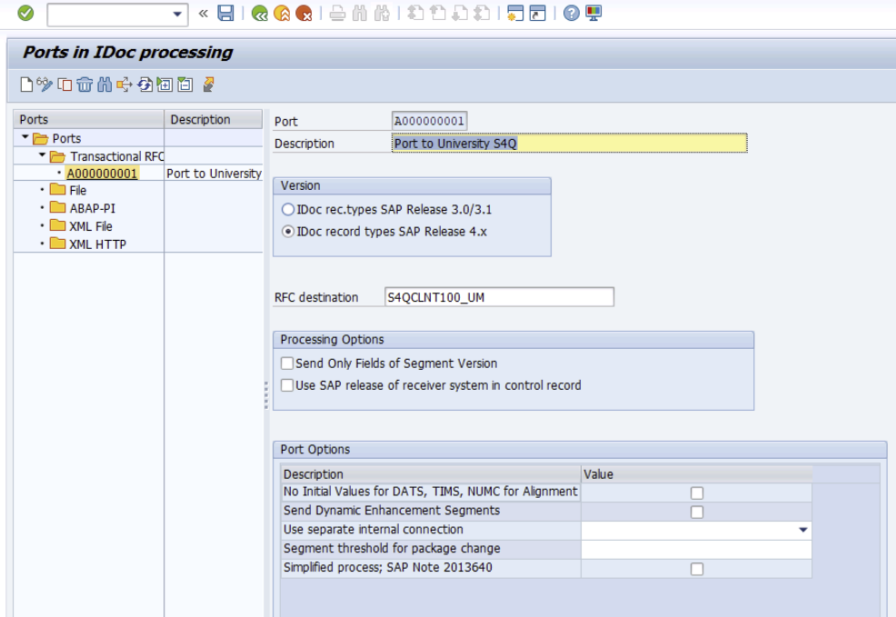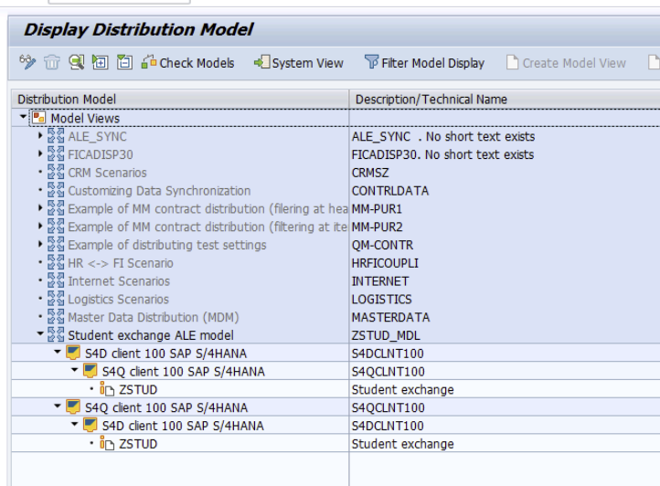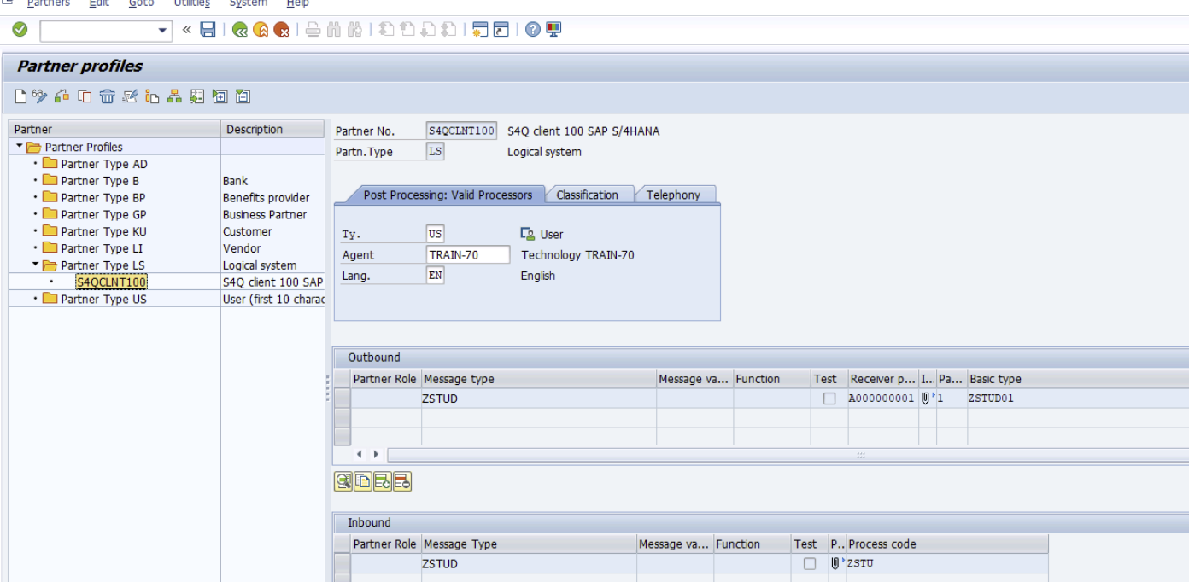

Phase 3: application layer
This is the code that brings the channel to life: it fills the IDoc on the way out and posts it on the way in.
- Sending report Z_STUD_SEND_ASSIGN (on DEV): reads a student from ZSTUD_STUDENT, fills the control record and the segments, then calls MASTER_IDOC_DISTRIBUTE. The receiver is determined by the model, not hard-coded.
- Inbound function module Z_IDOC_INPUT_ZSTUD (on QAS): follows the standard interface imposed by the framework (IMPORTING, EXPORTING, TABLES including SERIALIZATION_INFO). It loops over the segments and posts into ZSTUD_STUDENT, then returns the status (53 success, 51 error).
- Process code ZSTU (on QAS): registered in BD51, linked to the message type in WE57, created in WE42 with function-module processing through the ALE service.
- Inbound partner profile (WE20 on QAS): inbound parameter ZSTUD with process code ZSTU, in Trigger Immediately mode (the IDoc posts as soon as it arrives).
Result: both flows are validated end to end. A student created and assigned on DEV leaves as an IDoc, is received and posted on the QAS side; an event entered on the faculty side (QAS) travels back as an IDoc and updates the student's situation on the ministry side (DEV). A single message type ZSTUD, two basic types, two directions.
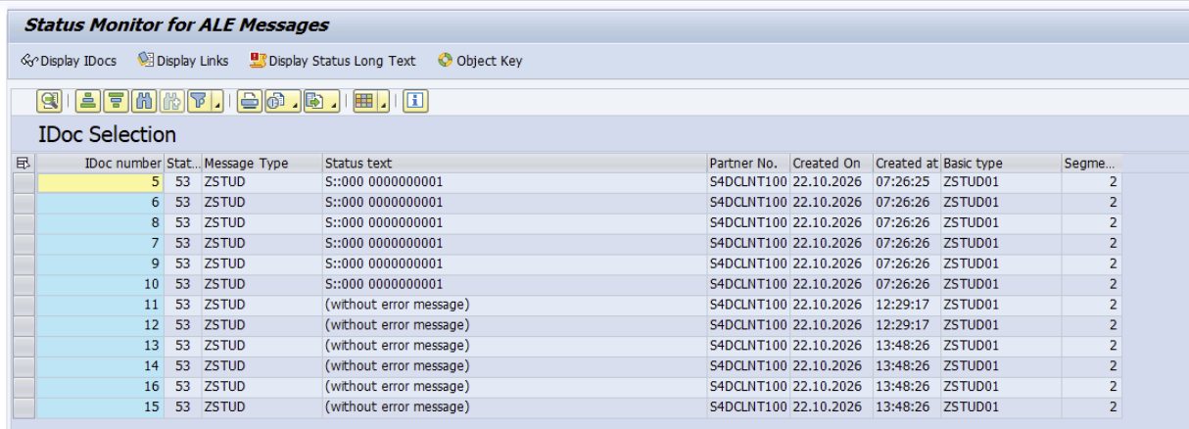
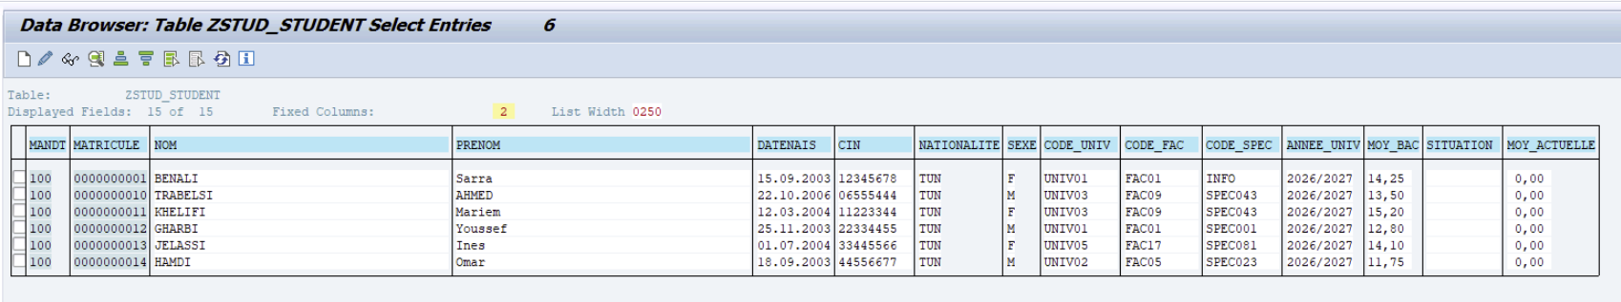

Phase 4: the operational layer
On top of the IDoc plumbing, we built a real usable application, with its transactions for each actor.
Reference data. Three master tables (ZSTUD_UNIV, ZSTUD_FAC, ZSTUD_SPEC) with maintenance screens (SM30), populated with 5 universities, 19 faculties and 97 specializations. The ministry is the master of this reference data. A function module Z_STUD_VALIDATE_AFFECT validates the university to faculty to specialization consistency at assignment time.
Ministry transactions (DEV):
- Create a student (ZSTUD_STU_CRE)
- Assign a student to a faculty/specialization, with cascading F4 input help and validation (ZSTUD_AFFECT)
- Mass import from a CSV file, with a downloadable template (ZSTUD_IMPORT)
- Mass assignment from a CSV file, with line-by-line validation and a log (ZSTUD_MASS_AFF)
Faculty transaction (QAS):
- Enter an event (ZSTUD_EVENT): result, average, university transfer, death, with dropdown lists; the transaction creates the event and sends the return IDoc
Student situation. Two fields (SITUATION, MOY_ACTUELLE) added to the master record, updated automatically by the inbound function module according to the event received (ADMIS, REFUSE, DECEDE, TRANSFERT). The record carries the current state, the ZSTUD_EVENT log keeps the full history.
Design point worth remembering: creating a student triggers no IDoc; it is the assignment that sends the student to the faculty. The ministry holds the complete list, the faculty receives only the students assigned to it.
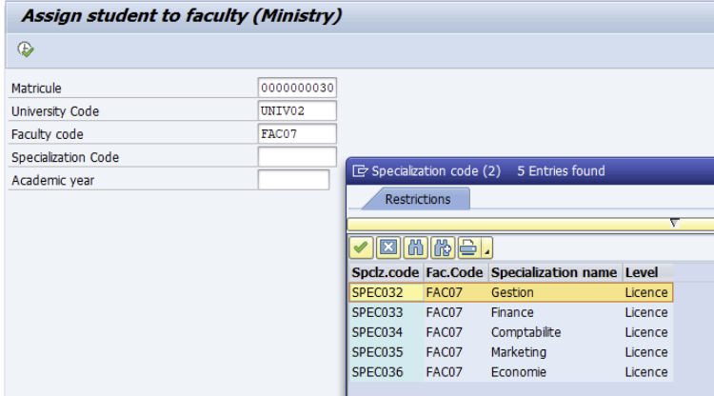

Pitfalls encountered and solutions
[image: image.png]

[image: image.png]
The real lessons of the project, the ones that block the most people on a custom ALE/IDoc build.
Symptom | Cause | Solution
abapGit: hand-forged offline ZIP rejected (CX_XSLT_FORMAT_ERROR) | The XML for DDIC/FUGR objects is strict (asXML, field order) and can't be built by hand | Create the objects natively in the transactions; use abapGit to version what SAP exported
Outbound error: "No entry in conversion table for external segment name Z2..." (EA274) | Empty release: SAP falls back to the 3.0/3.1 format, which doesn't accept long names | Release the segments AND the basic type (WE30, Set release), then regenerate a fresh IDoc
Inbound: "Unhandled inbound exception" (B1 069), with no ST22 dump | The framework caught an error from the inbound FM | Harden the FM (TRY/CATCH), and above all check its interface
WE19: "Interface for function ... is incorrect" | A mis-named TABLES parameter: SERIAL_NUMBERS instead of SERIALIZATION_INFO | Compare the interface with a standard FM (e.g. IDOC_INPUT_ORDERS) and align it exactly
Decimal conversion crashes (average) | Different decimal separator between sender and receiver | Normalize (comma to dot), check it is numeric, then convert
Distribution model (BD64) fails (missing SYNCH profile) | Distribution requires an RFC destination named after the logical system and a SYNCH profile | Simpler: define the model manually on each system
IDoc stuck in status 30 after sending | Partner profile in Collect mode | Switch to Transfer Immediately, or flush the queue with RSEOUT00 (schedulable as a job)
Inbound IDoc in error 51: No function module for input process code | The process code (WE42) on the receiver has no FM identification | Fill in the FM in the process code identification (WE42), on each receiving system
Cross-cutting rule to remember: any segment that travels through a port must be released, on both sides. It is the source of half the blockages.

Appendix: project objects
Complete inventory for assembling the transports.

Workbench objects
Type | Objects
Tables | ZSTUD_STUDENT (+ SITUATION, MOY_ACTUELLE), ZSTUD_EVENT, ZSTUD_UNIV, ZSTUD_FAC, ZSTUD_SPEC
Data elements | ZE_CODEUNIV, ZE_LIBUNIV, ZE_VILLE, ZE_CODEFAC, ZE_LIBFAC, ZE_CODESPEC, ZE_LIBSPEC, ZE_NIVEAU, ZE_ACTIF
Segments (WE31) | Z1STUHDR, Z1STUAFF, Z1EVTHDR, Z1EVTDAT
Basic types (WE30) | ZSTUD01, ZSTUD02
Function groups | ZSTUD_IDOC, ZSTUD_REF
Function modules | Z_IDOC_INPUT_ZSTUD, Z_STUD_VALIDATE_AFFECT
Reports | Z_STUD_SEED, Z_STUD_SEED_REF, Z_STUD_SEND_ASSIGN, Z_STUD_SEND_EVENT, Z_STUD_STUD_ENTRY, Z_STUD_AFFECT, Z_STUD_EVENT_ENTRY, Z_STUD_MASS_IMPORT, Z_STUD_MASS_AFFECT
Transactions (SE93) | ZSTUD_STU_CRE, ZSTUD_AFFECT, ZSTUD_EVENT, ZSTUD_IMPORT, ZSTUD_MASS_AFF

Customizing / ALE objects
Message type ZSTUD (WE81), WE82 links (ZSTUD + ZSTUD01, ZSTUD + ZSTUD02), process code ZSTU (WE42), FM/message link WE57, inbound FM attributes BD51, logical systems BD54 (DEVCLNT100, QASCLNT100), distribution model BD64 (ZSTUD_MDL).

Non-transportable objects (to create per system)
RFC destinations SM59 (QAS_UM, DEV_UM), tRFC ports WE21 (A000000001 on each side), partner profiles WE20 (QASCLNT100, DEVCLNT100: outbound and inbound), authorization role Z_BC_ZSTUD_RFC and technical user 8TECH_RFC.

Deployment: transport requests (TR)
The whole solution is packaged into two transport requests:
- DEVK900578 — Workbench (ALE Demo): tables, data elements, segments, basic types, function groups, function modules, reports, transactions.
- DEVK900580 — Customizing (ALE Demo): message type, WE82 links, process code, FM/message link (WE57), inbound FM attributes (BD51), logical systems (BD54), distribution model (BD64).
Import the Workbench request first, then the Customizing one. The manual configuration items listed under "Non-transportable objects" (RFC destinations, tRFC ports, partner profiles, authorization role, technical user) are not transportable and must be recreated by hand on each system, as documented above. Even if the exchange doesn't work on the very first run, it should work after the usual checks and a test cycle.
Cofiles (K9005xx.DEV) and data files (R9005xx.DEV) are published on GitHub: GitHub repository
Platform note: all objects were created on SAP_BASIS and SAP_ABA 758 SP04 (ABAP Platform 2023).

